

**Reading: Introduction to Google spreadsheets**

**Estimated time: 10 mins**

**Objective:**

* **Learn about Google spreadsheets**
* **Identifying Worksheet space**
* **Upload file**
* **Edit and format spreadsheets**
* **Keyboard shortcuts**

**Dataset:**

Dataset used in this reading is taken from data.world and related to superstore data. This dataset contains sales data related to different region like West, Central, South and East.

Dataset source: <https://data.world/haszeliahmad/sample-superstore-dataset-based-on-tableau/workspace/file?filename=Sample_Superstore_Data_One_Region_Per_Sheet.xlsx>

**Google spreadsheets:**

To create a spreadsheet, you should have a google account. In your account, you will get the Google Drive where you will find different options like,

* Google docs
* Google sheets
* Google slides
* Google forms and many more.

Google sheets are based on cloud environment and can be saved in drive only which you can access anytime. Spreadsheets are just like an Excel which is a form of tabular format where you can arrange your data in rows and columns.

Follow the steps to create the worksheet.

1. To create a Google sheet, you need can use the link:

sheets.google.com

1. Create you google account by providing the necessary details.
2. From Google Drive, locate and click **New.** Select **Google Sheets** to create a new sheet.

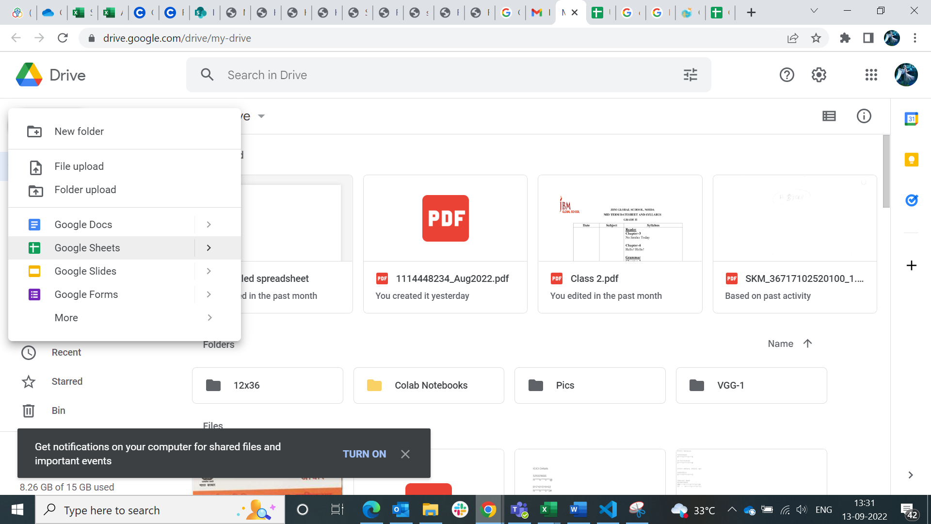

Once you select Google Sheets, you will get the new sheet as:

1. Let us first change the name of the sheet. Click on the sheet name.

Change the sheet name to **Superstore_Data**

**Identifying worksheet space:**

Let us discuss about the worksheet space.

Adding comments

Sharing option

Menu bar

Active sheet

Active cell

Function bar

Toolbar

**Menu bar:** In menu bar, you will get different tabs like File, Edit, View, Insert, Format, Data, Tools, Extensions and Help. Using these options, you can open the file, edit it, insert charts, columns, rows and many more.

**Toolbar:** Using toolbar, you can format the data in the spreadsheet like font color, alignment, font, font size, filter and many more.

**Function bar:** In function bar, you can write different formulas to edit the content like SUM, CONCAT and many more.

**Share**: You can share the google sheets with anyone. You can provide the permissions to only view or edit it.

**Comments:** You can add comments/notes to explain about a cell. You can also edit, delete and hide or show the comments.

**Upload a file**

To upload a file, click on **My Drive**, and select **File Upload**.

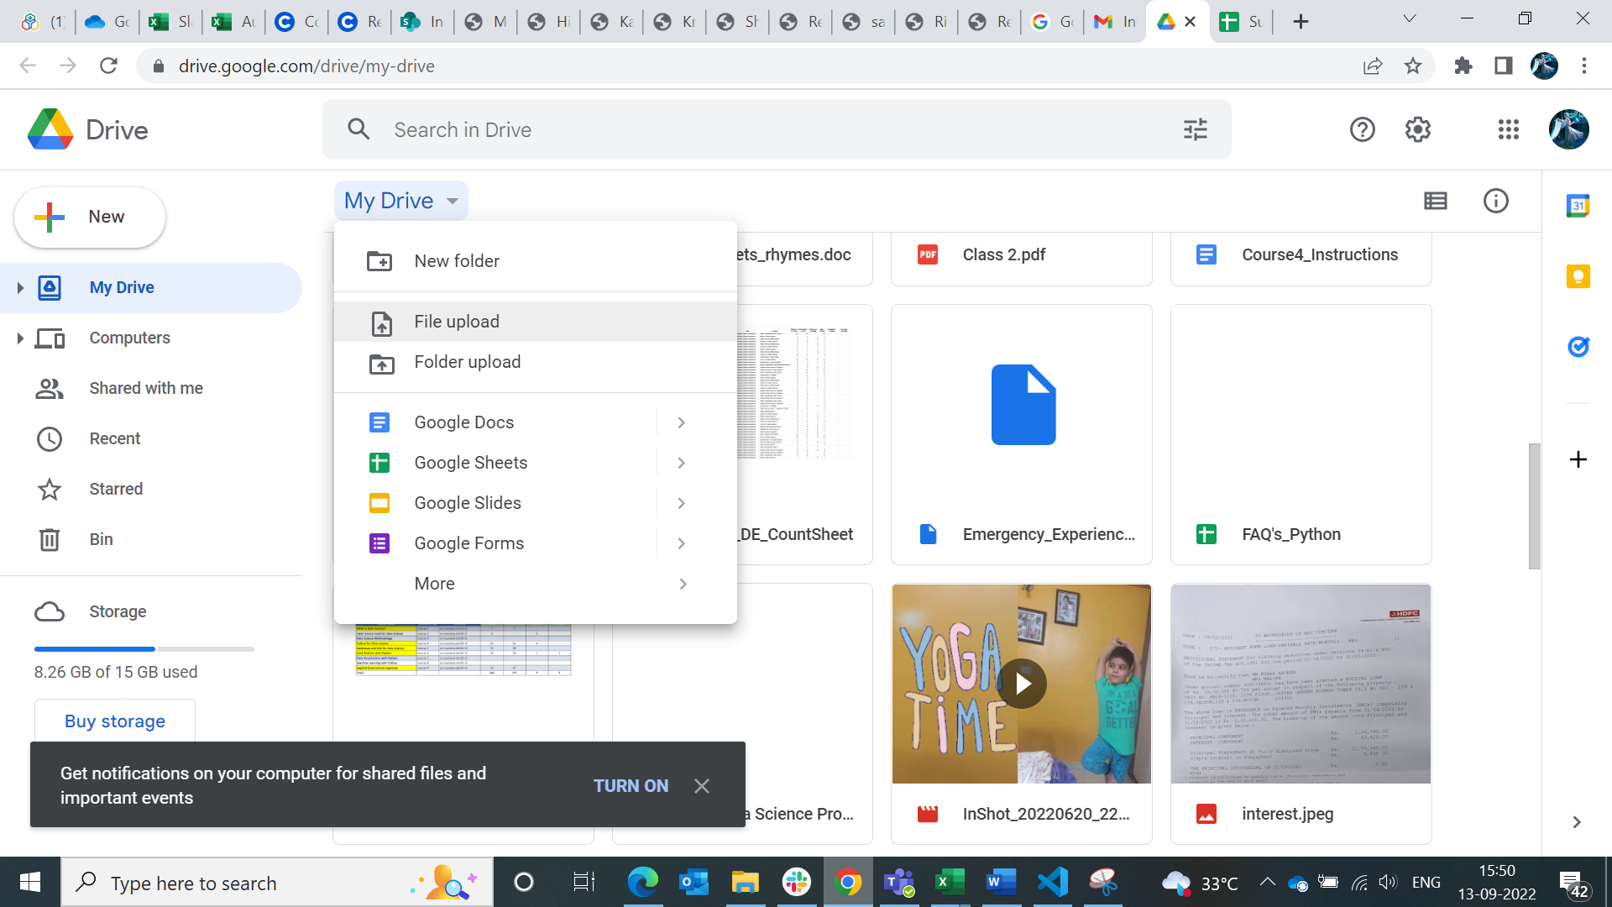

Browse the file and click Open.

Once upload finishes, you can see the file in your drive.

Go to your worksheet which you used earlier i.e., Superstore_Data and click File. Select Open to open the uploaded sample superstore file.

Select the file and click open.

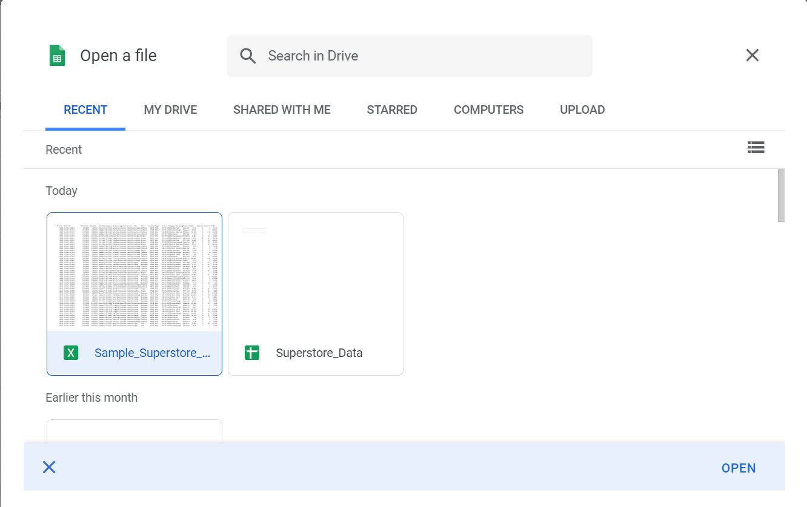

From the dropdown, use **Open with** and select **Google Sheets.**

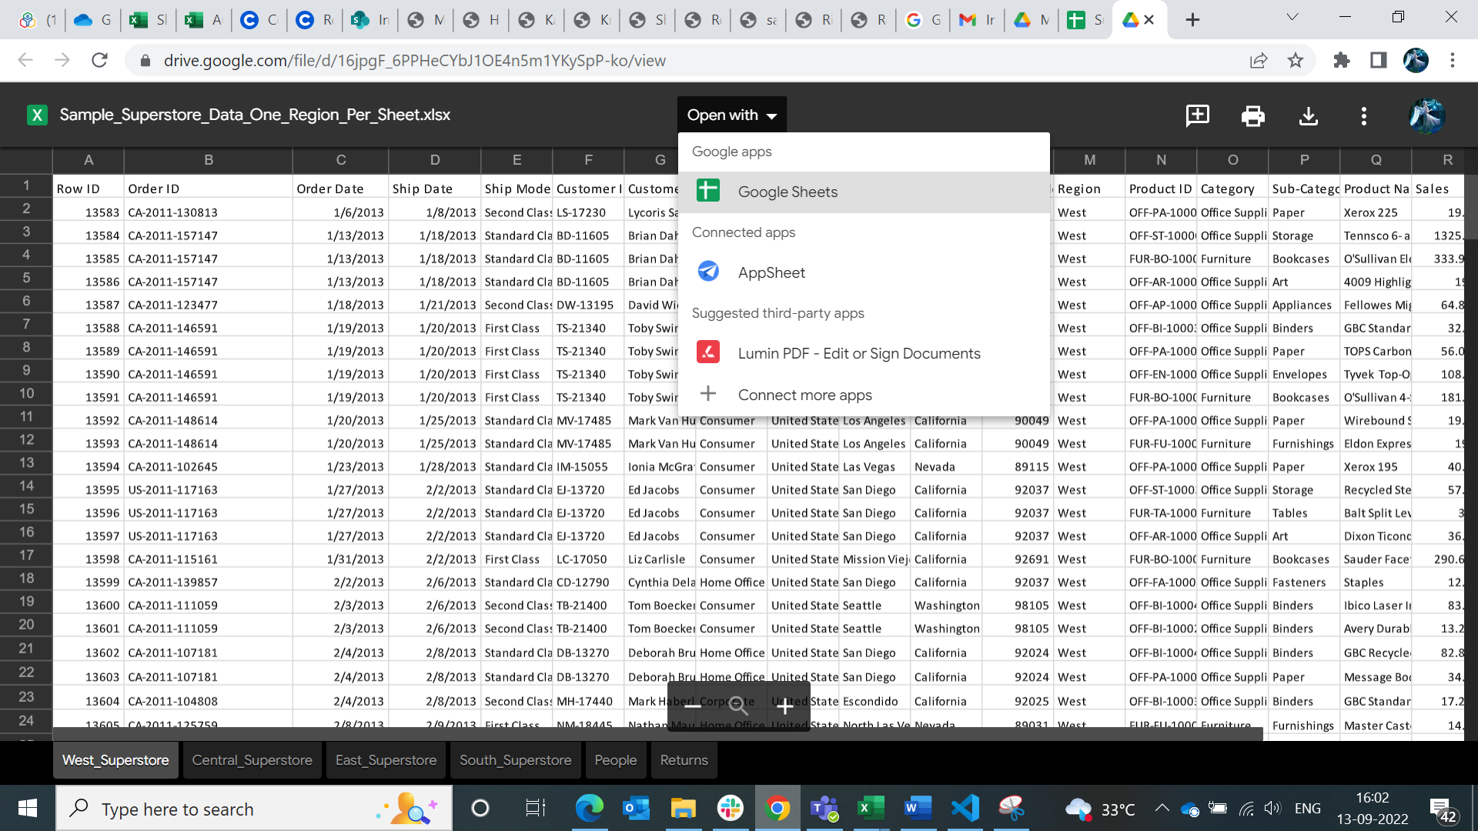

**Edit and format**

Select the complete file by clicking the area which is selected.

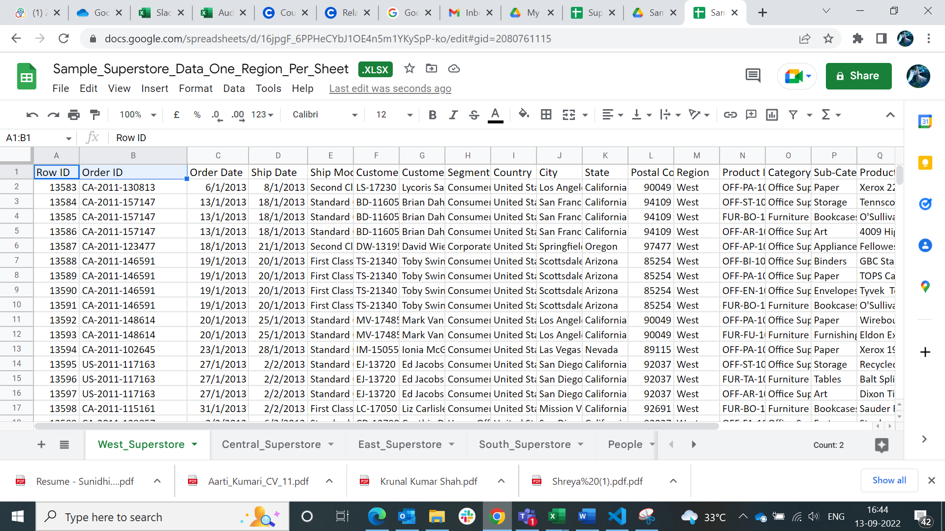

Click here

If you see, some of the column data we are not able to see as it is overlapping with the other data. So, to extend the column width, right-click the column you want to resize and select **Resize the column.**

**For example, column F – Customer ID**

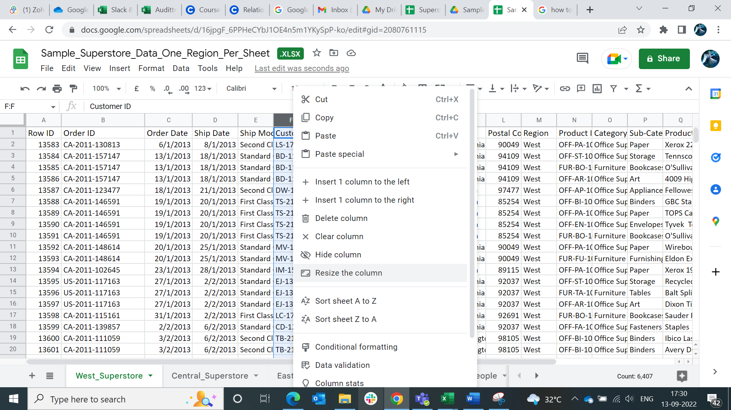

And then select the option as per the requirement.

Here, we are selecting **Fit to data.** Now, after using **Fit to data column F** looks as:

Same ways you can select the multiple columns by using Shift key and selecting the columns.

You can also check the spellings in the sheet using spell check option given in Tools tab.

You can then select to update or not to update as per the suggestions given.

Your file is automatically getting saved in your google drive with the status created, edited or opened.

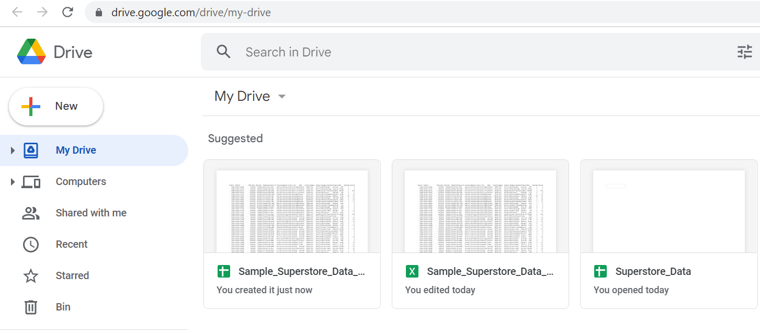

**Keyboard shortcuts**

|  |  |
| --- | --- |
|  | Shortcut |
| Open | Ctrl + O |
| Undo | Ctrl + Z |
| Redo | Ctrl + Y |
| Cut | Ctrl + X |
| Copy | Ctrl + C |
| Paste | Ctrl + V |
| Paste Special | Ctrl + Shift + V |
| Paste format only | Ctrl + Alt + V |
| Group | **Alt + Shift +** |
| Sheet | **Shift + F11** |
| Link | **Ctrl + K** |
| Comment | **Ctrl + Alt + M** |
| Note | **Shift + F2** |
| Bold | **Ctrl + B** |
| Italic | **Ctrl + I** |
| Underline | **Ctrl + U** |
| Strike-through | **Alt + Shift + 5** |
| Alignment Left | **Ctrl + Shift + L** |
| Alignment Centre | **Ctrl + Shift + E** |
| Alignment Right | **Ctrl + Shift + R** |

**Let’s get started with basic functions that you can use in spreadsheet.**